## ABMS (American Board of Medical Specialties)

For more than 75 years, the American Board of Medical Specialties (ABMS) has been the medical organization overseeing physician certification in the United States. It assists its 24 Member Boards in their efforts to develop and implement educational and professional standards for the evaluation and certification of physician specialists. ABMS Member Boards provide physician certification information to ABMS for its certification verification service programs. ABMS is recognized by the key health care credentialing accreditation entities as a primary equivalent source of Board Certification data for medical specialists. Patients can visit www.CertificationMatters.org or call toll-free (866) ASK-ABMS to see if their physician is Board Certified by an ABMS Member Board. For more information about ABMS, visit www.abms.org or call (312) 436-2600.

The 24 Member Boards that comprise the ABMS Board Enterprise and certify nearly 800,000 physicians include the American Board of Allergy and Immunology, American Board of Anesthesiology, American Board of Colon and Rectal Surgery, American Board of Dermatology, American Board of Emergency Medicine, American Board of Family Medicine, American Board of Internal Medicine, American Board of Medical Genetics, American Board of Neurological Surgery, American Board of Nuclear Medicine, American Board of Obstetrics and Gynecology, American Board of Ophthalmology, American Board of Orthopedic Surgery, American Board of Otolaryngology, American Board of Pathology, American Board of Pediatrics, American Board of Physical Medicine and Rehabilitation, American Board of Plastic Surgery, American Board of Preventive Medicine, American Board of Psychiatry and Neurology, American Board of Radiology, American Board of Surgery, American Board of Thoracic Surgery and American Board of Urology.

## Certification is accomplished through a comprehensive process involving educational requirements, professional peer evaluation, examination, and professional development.

## ABMS certify specialists in more than 150 medical specialties and sub-specialties.

## ABMS-MOC (Maintenance of Certification) is a certification program for physicians which is certified by the ABMS

* Board Certification is very different from medical licensure. Obtaining a medical license sets the minimum competency requirements to diagnose and treat patients, it is not specialty specific.
* Board Certification demonstrates a physician’s exceptional expertise in a particular specialty and/or subspecialty of medical practice.
* Board Certification helps Physician to compare their practice with others Physicians, how it differs from published best practices, and how their own practice evolves over time, progressing toward the ideal practice.
* Board Certification and the ABMS Program for Maintenance of Certification (ABMS MOC®) are highly-visible indicators that physicians know today’s standards of practice.

**Note : When a physician or surgeon is Board Certified by an ABMS specialty board, it means he or she has chosen to achieve expertise in a medical**[**specialty or subspecialty**](http://www.abms.org/member-boards/specialty-subspecialty-certificates/)**by meeting the profession-driven standards and requirements of one (or more) of the**[**24 ABMS certifying boards**](http://www.abms.org/member-boards/contact-an-abms-member-board/)**.**

[**https://en.wikipedia.org/wiki/Board_certification**](https://en.wikipedia.org/wiki/Board_certification)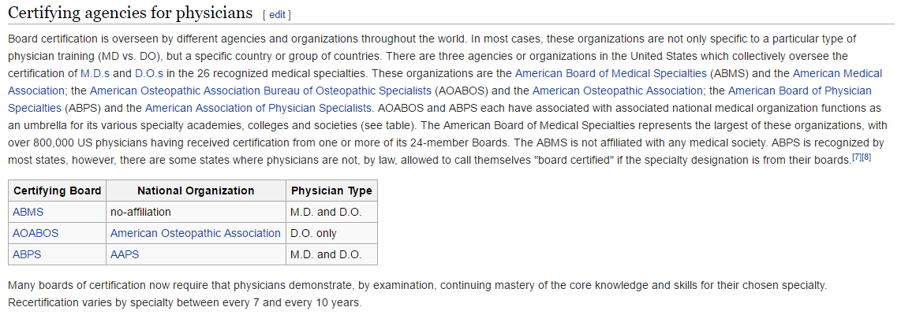

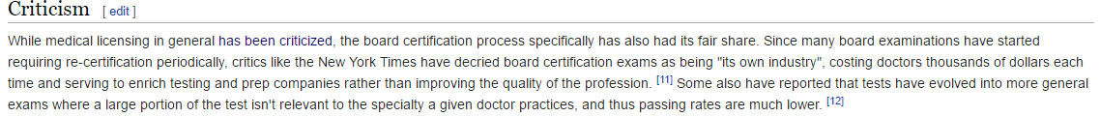

BOARD CERTIFICATION

* ABMS-MOC
* ABMS Program for MOC is a system of ongoing professional development and practice assessment and improvement.
* The ABMS Program for MOC activities are the ways which physicians demonstrate their ability to provide high-quality care for the diagnosis and treatment of disease, promotion of health and prevention of disease, and the physical and emotional support of patients and families.
* It challenges physicians to focus on the continuous development of their skill set, especially those skills that enable them to function effectively in interprofessional teams, integrated systems of care, and community settings.
* Patients, physicians, health care providers, insurers, and quality organizations look for these markers as the best measure of a physician’s knowledge, experience and skills to provide quality health care within a given specialty.
* Physicians meet the standards set by ABMS in order to become Board Certified. [Standards](http://www.abms.org/news-events/abms-approves-new-standards-for-physician-certification-program/) guiding the ABMS Program for Maintenance of Certification (ABMS MOC®) are patient-centric with a greater emphasis on professionalism, patient safety, and performance improvement.
* It helps physicians become active participants in the evaluation of their own practices.

**Note : Board Certification and the ABMS Program for Maintenance of Certification (ABMS MOC®) are highly-visible indicators that physicians know today’s standards of practice.**

# Assessed Through a Four-Part Framework

The four part process reflects evidence-based guidelines, national clinical and quality standards, and specialty best practices.

The four-part MOC process includes:

Part I: Professionalism and Professional Standing

* Behave in a professional manner
* Act in the patients’ best interest
* Hold a valid, unrestricted medical license

[Part II: Lifelong Learning and Self-Assessment](http://www.abms.org/media/84748/abms_memberboardsrequirementsproject_moc_partii.pdf)

* Participate in high quality, unbiased educational and self-assessment activities determined by each Member Board

Part III: Assessment of Knowledge, Judgment, and Skills

* Pass a written examination and other evaluations

[Part IV: Improvement in Medical Practice](http://www.abms.org/media/84747/abms_memberboardsrequirementsproject_moc_partiv.pdf)

* Engage in ongoing assessment and improvement activities to improve patient outcomes
* Demonstrate use of evidence and best practices compared to peers and national benchmarks

ABMS Solutions LLC.

* ABMS Solutions LLC is the subsidiary of American Board of Medical Service (ABMS).
* These resources allow hospitals and health systems as well as attorneys, insurance groups, and other professionals to check physician’s records quickly, conveniently, and securely.

<http://www.abmssolutions.com/product-solutions/certifacts-online/>

ABMS Solutions Products

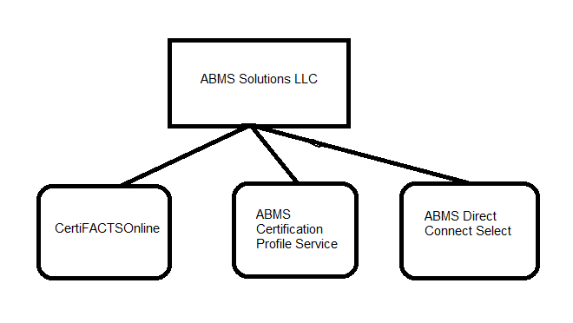

CertiFACTS Online®

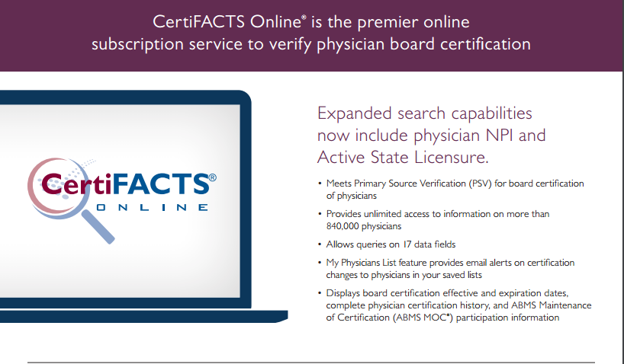

http://www.abmssolutions.com/media/99966/certifacts_streamline.pdf

Direct Connect® Select

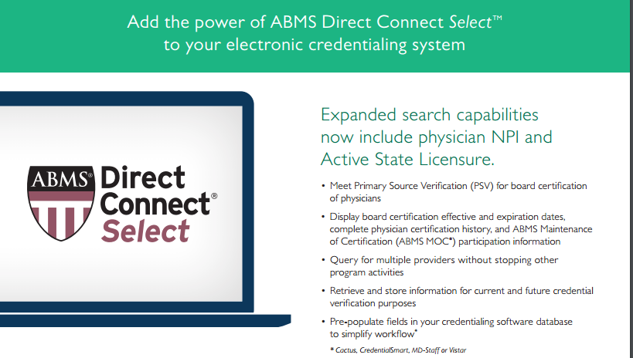 http://www.abmssolutions.com/media/99967/dc_select_integrate.pdf

<http://www.abim.org/credentialers/default.aspx>

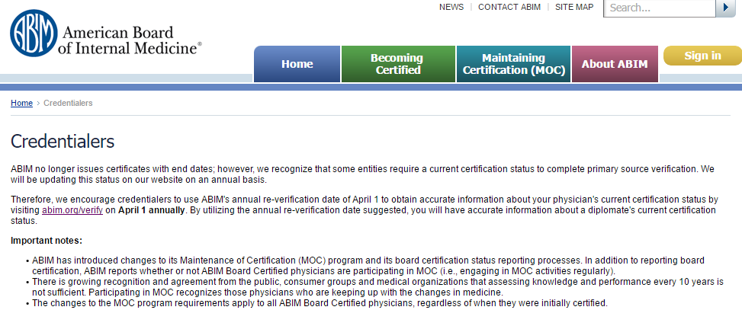

<http://www.abim.org/certification/policies/general/policies.aspx#eligibility>

